Name: P. Sai Hallticket:2303A52395 Assginment:7.1 Task:01
(Syntax Errors – Missing Parentheses in Print Statement)
Task: Provide a Python snippet with a missing parenthesis in a print statement (e.g., print "Hello"). Use AI to detect and fix the syntax error.
# Bug: Missing parentheses in print statement def greet():
print "Hello, AI Debugging Lab!" greet()
Requirements:
- Run the given code to observe the error.
- Apply AI suggestions to correct the syntax.
- Use at least 3 assert test cases to confirm the corrected code
works.
Code:

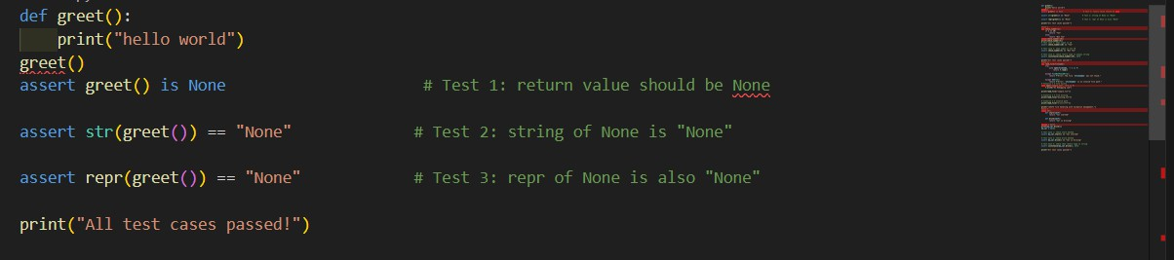

Output:
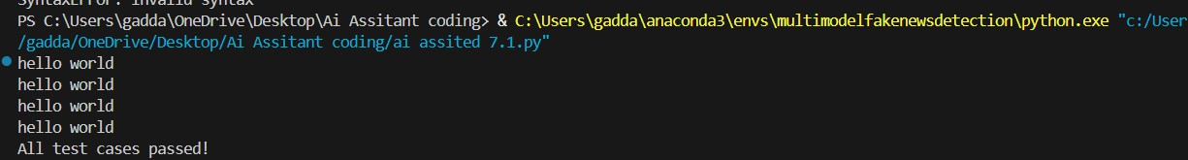
Observation1:
- Missing parentheses in print causes a syntax error in modern Python.
- Adding parentheses corrects the syntax and allows the program to run.
- The corrected function behaves properly and can be verified using assert tests.
Task2:
ask: Supply a function where an if-condition mistakenly uses = instead of ==. Let AI identify and fix the issue.
# Bug: Using assignment (=) instead of comparison (==) def check_number(n):
if n = 10:
return "Ten" else:
return "Not Ten" Requirements:
- Ask AI to explain why this causes a bug.
- Correct the code and verify with 3 assert test cases.
Expected Output #2:
- Corrected code using == with explanation and successful test
Execution
Code:

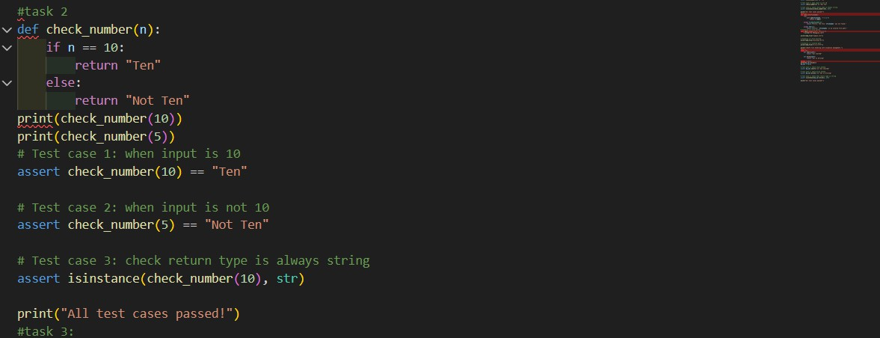
Output :
Observation2:
Using = in an if condition causes a syntax error in Python. Replacing it with == correctly compares values and fixes the bug.
The corrected function works as expected and passes all assert tests.

Task3:
Task: Provide code that attempts to open a non-existent file and crashes. Use AI to apply safe error handling.
# Bug: Program crashes if file is missing def read_file(filename):
with open(filename, 'r') as f: return f.read() print(read_file("nonexistent.txt")) Requirements:

- Implement a try-except block suggested by AI.
- Add a user-friendly error message.
- Test with at least 3 scenarios: file exists, file missing, invalid
path.
Expected Output #3:
- Safe file handling with exception management. Code:
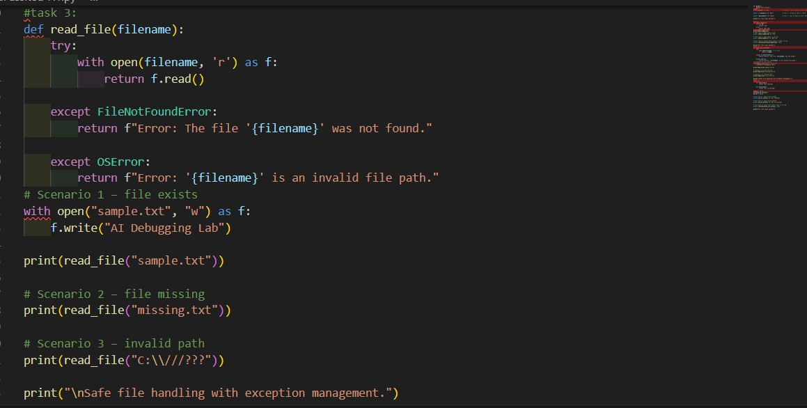
Output:
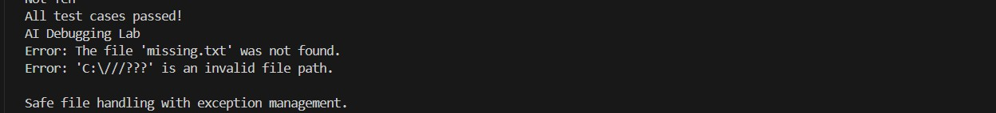
Observation3:
- Attempting to open a missing file without handling exceptions causes the program to crash.
- Using a try–except block allows the program to handle errors safely with a user-friendly message.
- Testing with different scenarios confirms that the file handling works reliably in all cases.

Task4:
Task Description #4 (Calling a Non-Existent Method)
Task: Give a class where a non-existent method is called (e.g., obj.undefined_method()). Use AI to debug and fix.
# Bug: Calling an undefined method class Car:
def start(self):
return "Car started" my_car = Car()
print(my_car.drive()) # drive() is not defined Requirements:
- Students must analyze whether to define the missing method
or correct the method call.
- Use 3 assert tests to confirm the corrected class works.
Expected Output #4:
- Corrected class with clear AI explanation. Task Description #4 (Calling a Non- Existent Method)
Task: Give a class where a non-existent method is called (e.g., obj.undefined_method()). Use AI to debug and fix.
# Bug: Calling an undefined method class Car:
def start(self):
return "Car started" my_car = Car()
print(my_car.drive()) # drive() is not defined Requirements:

- Students must analyze whether to define the missing method
or correct the method call.
- Use 3 assert tests to confirm the corrected class works.
Expected Output #4:
- Corrected class with clear AI explanation.
Code:

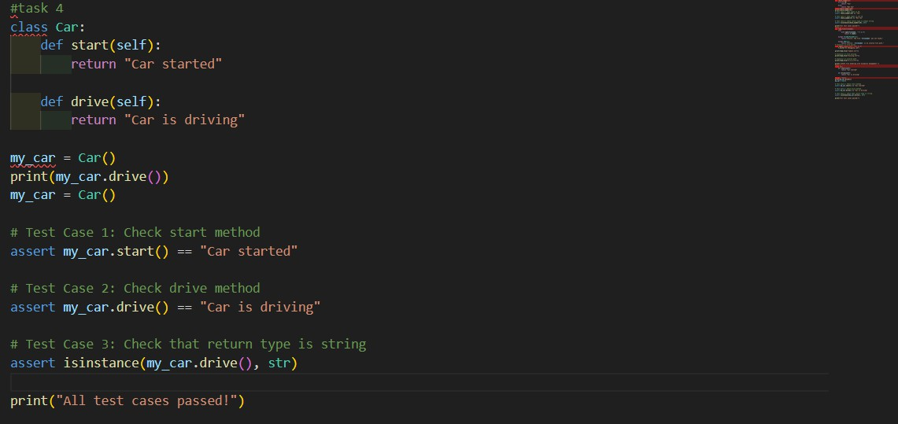
Output:

Observation4:
- Calling a method that is not defined in a class causes an AttributeError.
- The bug can be fixed either by adding the missing method or correcting the method call.
- After correction, the class works properly and is verified using assert tests.

Task 5:
Task Description #5 (TypeError – Mixing Strings and Integers in Addition)

Task: Provide code that adds an integer and string ("5" + 2) causing a TypeError. Use AI to resolve the bug.
# Bug: TypeError due to mixing string and integer def add_five(value):
return value + 5 print(add_five("10")) Requirements:
- Ask AI for two solutions: type casting and string
concatenation.
- Validate with 3 assert test cases.
Code:

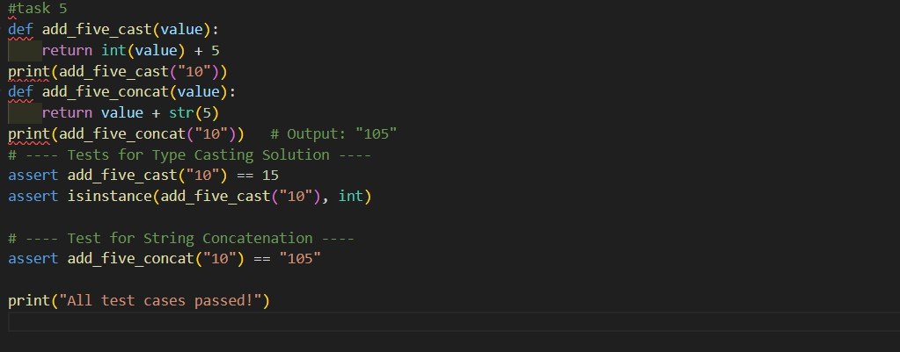
Output:

Observations 5:
Python raises a TypeError when adding a string and an integer directly. The error can be fixed either by type casting or string concatenation.
AI helps identify the bug and suggests correct and working solutions.

